**CSE-105: Structured Programming Language**

Topic: Variable & Data Types

* Nafiz Imtiaz Khan

Lecturer, Department of CSE, MIST Email: nafiz@cse.mist.ac.bd

1

**Variables **

❏ A **variable** is a name of the memory location that is used to store data.

❏ During the execution of the program, a variable may take different values at different time. ❏ A variable can be reused many times.

❏ It is a way to represent memory location through symbol so that it can be easily identified. 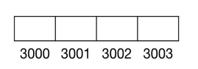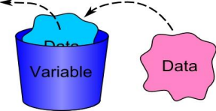

2

07/10/2021 Topic: Variable and Data Types

**Rules to declare variables **

❏ Variable name must begin with letter or underscore (_).

❏ Variables are case sensitive

❏ They can be constructed with digits, letters.

❏ No special symbols are allowed other than underscore (_) and dollar sign ($).

❏ sum, height, _value are some examples for variable name



3

07/10/2021 Topic: Variable and Data Types

**Declarations of variables **

❏ Syntax: data_type variable_name;

❏ **Example**:

int x, y, z, a, b, c;

float x, y, z, abd, def;

double x;

char c, d;

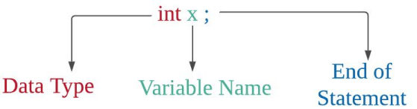

4

07/10/2021 Topic: Variable and Data Types

**Assigning values to variables **

❏ Assignment operator is used to assign values to variables.

❏ Example: 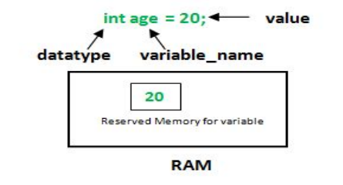

X = 10;

Y = 20;

C = ‘A’;

5

07/10/2021 Topic: Variable and Data Types

**Valid or Invalid eclaration **int 123pc; NOT VALID

int pc123; VALID

int _pc123; VALID

int ab@123; NOT VALID

6

07/10/2021 Topic: Variable and Data Types

**Data Types Types Data Types**

Basic data types int, char, float, double

Enumeration data type enum

Derived data type pointer, array, structure, union

Void data type void

07/10/2021 Topic: Variable and Data Types 7 Nafiz Imtiaz Khan Regression Analysis

**Basic Data Types **

Each variable in C has an associated data type. Each data type requires different amounts of memory and has some specific operations which can be performed over it.

Following are the examples of some very common data types used in C:

❏ **char**

❏ **int**

❏ **float**

❏ **double**

07/10/2021 Topic: Variable and Data Types 8 Nafiz Imtiaz Khan Regression Analysis

**‘char’ Data Type **

❏ Character data type allows a variable to store only one character.

❏ “char” keyword is used to refer character data type.

❏ For example, ‘A’ can be stored using char data type. You can’t store more than one character using char data type.

❏ **Storage size**: 1 byte 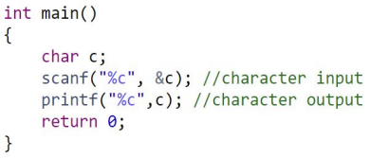

❏ **Range**: -128 to 127 (ASCII Values)

❏ **Format Specifier**: “%c”

9

07/10/2021 Topic: Variable and Data Types

**Character Modifiers**

**Data Type Memory (byte)**



**Range Format Specifier**

signed char 1 -128 to 127 %c

unsigned char 1 0 to 255 %c

10

07/10/2021 Topic: Variable and Data Types

**‘int’ Data Type **

❏ Integer data type allows a variable to store numeric values.

❏ “int” keyword is used to refer integer data type.

❏ The storage size of int data type is 2 or 4

❏ **Storage**: 2 or 4 byte

❏ **Range**: -32,768 to +32,767 (2 byte); -2,147,483,648 to +2,147,483,647 (4 byte) ❏ **Format Specifier:** “%d”

11

07/10/2021 Topic: Variable and Data Types

**Integer Modifier **

| **Data Type** |
| --- |
| short int |
| unsigned short int |

**Memory (byte) Range Format Specifier** 2 -32,768 to 32,767 %hd 2 0 to 65,535 %hu

unsigned int 4 0 to 4,294,967,295 %u long int 4 -2,147,483,648 to 2,147,483,647 %ld unsigned long int 4 0 to 4,294,967,295 %lu long long int 8 -(2^63) to (2^63)-1 %lld

unsigned long long int

8 0 to 18,446,744,073,709,551,615 %llu

12

07/10/2021 Topic: Variable and Data Types

**‘float’ Data Type **

❏ Float data type allows a variable to store decimal values.

❏ We can use up-to 6 digits after decimal using float data type.

❏ For example, 10.456789 can be stored in a variable using float data type.

❏ **Storage size**: 4 byte

❏ **Range**: 1.2E-38 to 3.4E+38 

❏ **Format Specifier:** “%f”

13

07/10/2021 Topic: Variable and Data Types

**‘double’ Data Type **

❏ Double data type is also same as float data type which allows up-to 10 digits after decimal.

❏ **Storage size**: 8 byte

❏ **Range**: 2.3E-308 to 1.7E+308

❏ **Format Specifier:** “%lf”

14

07/10/2021 Topic: Variable and Data Types

**Double Modifiers **

| **Data Type** |
| --- |

**Memory (byte) Range Format Specifier**

long double 16 3.4E-4932 to

1.1E+4932

07/10/2021 Topic: Variable and Data Types

%Lf

15

**Memory Allocation **

16

07/10/2021 Topic: Variable and Data Types

**Setting Decimal Precision in C **



17

07/10/2021 Topic: Variable and Data Types

**Determining the Size of a Variable **

18

07/10/2021 Topic: Variable and Data Types

**‘Void’ Data Type **

❏ Void is an empty data type that has no value.

❏ We use void data type in functions when we don’t want to return any value to the calling function.



returns nothing returns an integer value

19

07/10/2021 Topic: Variable and Data Types

**Constant **

❏ It is fixed value that do not change during the execution of a program.

❏ **Constant declaration:** #define constant_name value



20

07/10/2021 Topic: Variable and Data Types

**Constant **

❏ Naming rule is the same as naming a ***variable***.

❏ #define must be written before defining a constant

❏ At least one blank space between #define and symbolic name and between the symbolic name and constant.

❏ #define statement must not end with a semicolon

❏ After defining the symbolic name should not be assigned any other value in the program

21

07/10/2021 Topic: Variable and Data Types

**Valid or Invalid Constant Declaration **#define A = 21 NOT VALID

#define A 20; NOT VALID

#Define A 15 NOT VALID

#define A 11 VALID

22

07/10/2021 Topic: Variable and Data Types

**Keywords in C **

A keyword is a **reserved word**. It cannot be used as a variable name, constant name, etc. There are only 32 reserved words (keywords) in the C language.

A list of 32 keywords in the c language is given below:

auto break case char const continue default do

double else enum extern float for goto if

int long register return short signed sizeof static struct switch typedef union unsigned void volatile while

23

07/10/2021 Topic: Variable and Data Types

**Data Type Conversion **❏ Converting one data type into another is known as type casting or, data type conversion. Two types of conversion:

❏ **Implicit** – The change is implied. Here the conversion is done automatically from one data type to another.

❏ **Explicit** – The change is explicitly done with an operator or function. Programmer change or cast a value from one data type to another

24

07/10/2021 Topic: Variable and Data Types

**Implicit Type Conversion **❏ If the operands are of different type the lower type is automatically converted to the higher type before the operation proceeds. The result is of higher type.

❏ **Example**: A float type variable will be converted to double type automatically **Output**:

25

07/10/2021 Topic: Variable and Data Types

**Explicit Type Conversion **❏ Conversion from higher type to lower type requires explicit conversion.

❏ **Example**: Double to float conversion/ Float to int conversion



**Output**:

26

07/10/2021 Topic: Variable and Data Types

**Type Conversion Example **

**Example Action**

X = (int) 3.5 3.5 is converted to integer

X = (int)(a+b) The result of (a+b) is converted to integer X = (int)a+b a is converted to integer and then added with b

X = (int)a/ (int)b a is converted to int, b is converted to int, then division operation performed

X = (int)20.5 /(int)4.33

20.5 converted to floor int(20), 4.33 converted to floor int(4), then division operation performed

27

07/10/2021 Topic: Variable and Data Types

**Common mistakes to avoid **

❏ Don’t make a new project. Because:

❏ Projects usually have one main file

❏ But we require individual main files each with its own main function

❏ Do the following:

❏ In the codeblocks IDE :

❏ File->New->Empty File

❏ Save the file at the desktop (example format: 202114001_p1.c)

❏ Repeat the above steps for each of the problems

28

07/10/2021 Topic: Variable and Data Types

**Thanks**

Do you have any questions?

29